Dalton Murray

Human Computer Interaction

INT 3603 - 3452-202320_INT3603_OL

Professor Darren Hood

Sunday, February 19, 2022

**Assignment 2**

All images can be found labeled here: <https://drive.google.com/drive/folders/1nZUPWk0s2b-4UH2HBQA-kfiX3ZpoZogZ?usp=sharing> (Some will be included at end of document but there are far too many to include, recommend looking at the Google Drive.)

**Task Analysis**

Overview. The task analysis which I am going to be performing is on the website Mini USA, which is a car manufacturer/dealership owned by BMW. I am going to be listing everything which I find interesting or important in order to customize and purchase a vehicle from the landing page of the website and describe what I felt about the overall process. When performing this task analysis, I am going to be acting like a regular user who is viewing the website for the first time.

Steps. The overall steps which I have performed are as follows: Arrive on landing page -> Scrolled down through the page to look at all the pictures on it -> Scrolled back up -> Clicked the Build button in the navigation -> Scrolled down and looked at all the cars -> Compared prices and looks -> Decided to choose the Mini Clubman -> Pressed select -> Compared the engine options and selected the checkbox for the John Cooper Works ALL4 all wheel drive engine -> Selected next / trim in the bottom right corner -> Compared the features of the two trims and chose the Iconic Trim 2.0 -> Clicked next / interior -> Tried to move the 3d model of the car around then realized had to click it first then could move it -> Closed the 3d model -> Liked the default midnight black II color and clicked next / roof -> Liked roof in body color and chose next / wheels -> Compared the different wheels and chose the 19” circuit spoke wheels -> Clicked next / upholstery -> Changed the upholstery to a leather cross punch carbon black -> Clicked next / surface -> Compared surfaces and chose the MINI yours interior style piano black illuminated -> Clicked next / transmission -> Clicked the only available transmission -> Clicked next / packages -> Looked through the packages and decided to skip them -> Chose next / options -> Did not want any of the options and chose next / summary -> Viewed the summary, cost, options, and demo pictures -> Closed page

Summary of task analysis. From the start of the landing page, I was able to easily find out everything that I wanted. The website had a consistent design and theme and fit in with standards of other websites today. I was able to search through the landing page and look at images and get ideas of cars which I may be interested in. I then chose the build button at the top of the page and saw 5 different cars which they offer to be customized and built. I looked at the images of them all and compared them with their prices and chose the Mini Clubman car.

After selecting a car everything I had to do was very straightforward. It greeted me with two options for the engine, and then told me what I needed to do after that by having a big blue select next button. The trim page was a little confusing for me when I initially performed this task analysis because I thought there might have been pictures which were supposed to be there like all other pages but there was not. However, at the bottom of the page there was a list of features for the two trim options. I selected the one I wanted, and then pressed next again. On this page of colors I was at first confused why I couldn’t just spin around the car and look at it until I realized I had to click first and then would be able to interact with the 3D model. I noticed; however, I was locked to horizontal rotations and not able to fully interact with it by also going vertically. After closing this, I selected the color I wanted, and pressed next again. I looked through the different options of roofs and mirrors and selected the one I wanted and then next again for wheels. I then compared the different wheel options, selected the one I wanted, and clicked next again. I then selected an upholstery option, clicked next again, and then an interior surface and then next and a transmission and then pressed next to see available packages. This page I thought was interesting because almost all of the packages would require me to remove and change things which I already purposefully selected. I think it would make more sense to have the packages page before everything else as it seems like its only purpose is to try to upsell you and not actually make the car you like. I looked through them and didn’t choose one and pressed next to options. This page similar to the last it’s recommending me changes to things which I have already selected, this should be after the packages page at the beginning and then change my options in building the car to only see ones which fit with the package and options. I then viewed the summary paged and saw all of my choices and options I selected and reviewed it. I really like in this page at the bottom they include example pictures with your selected choices. I then closed the page.

Final thoughts. Everything on the website was very straightforward and easy to use and even more simple on the building page itself. It gave you the options and then made it obvious where to go from there. In terms of formatting of the build, I would only change around some of the things such as the packages and options pages to be at the start rather than at the end and then influence the options which you can choose. For example, so what is in your package, or show what is outside of the package and how selecting what would change your price.In terms of actual design of the website out of this, I felt like some design choices and formatting should be changed. There are also some text styles which I personally do not like. The landing page, for example, felt a little too cluttered to me, it had too much going on. Some pages were also a little laggy such as when interacting with the visual/3D models.

Tesla comparison. When comparing the landing page of Mini USA to something like Tesla’s landing page, I like Tesla’s much more. It is very clean and simple, having a main page, a title, and a small menu at the top. It is very much more visual in comparison. I also did a quick task analysis of Tesla’s website and felt like it had the same level of efficiency but was just more visually pleasing. I selected the Model X Plaid, and the entire screen is a big picture of it with minimal text, at the bottom it gave me some statistics about it like range, and horsepower. When clicking buy now it gives me all of the options I need on one page. It also does not have any lag when changing options and interacting with the model of the car.

**Memory and Cognitive Performance**

Some aspects of memory and cognitive performance have already been combined into the task analysis portion of this assignment, however, I am going to restate them and add more in this section.

I did not personally feel any real strain on memory or cognitive performance on the website. Everything from the landing page to the summary page of the building of the vehicle were very straightforward. However, a couple of the pages were a little cumbersome and unnecessary to me.

Main complaint. The first thing which I would change is the main design throughout the website. When comparing it to something like Tesla’s landing page and builder I noticed quite a few differences. Although, I am not personally a fan of Tesla or Elon Musk, I have to give it to them that the website looks very nice. Mini USA’s landing page at first glance does not look too bad, but when getting into it a lot of images take a little while to load, even on a very good Internet connection, and just felt like there was too much text everywhere. I believe that they should do a whole new design where it primarily focuses on images, like Tesla’s website.

Second complaint. My second and only real complaint with memory and cognition outside of general design and formatting is the builder. The 3D models take a long time to load and when interacting with them there seem to be virtual limitations put in place, such as only being able to move horizontally rather than also vertically and look everything on the main outside 3D model of the vehicle. On top of this, they include a packages page at the end of the build process, and a separate options page. These pages need to be at the start and then influence build choices throughout it rather than have them at the end and want you to change everything about your vehicle so you can fit it into the package. It makes much more sense to me to have them at the start and then show what options are in the packages and options throughout the build process, and then also show what options are not in the packages so that we can see more options and determine price with and without the packages and options. How it is right now is that you build your vehicle, then get to the packages page which then shows you some available packages but in order to use them requires you changing half of your options you already selected.

I think they did a really good job on this website but need to make it more visual with pictures rather than so much text everywhere. There wasn’t anything really confusing or not straight forward or anything I had to really think to figure out. They also have a very consistent layout among the pages which makes it easier for someone to know exactly where to look and what to do to change between pages.

**Images**

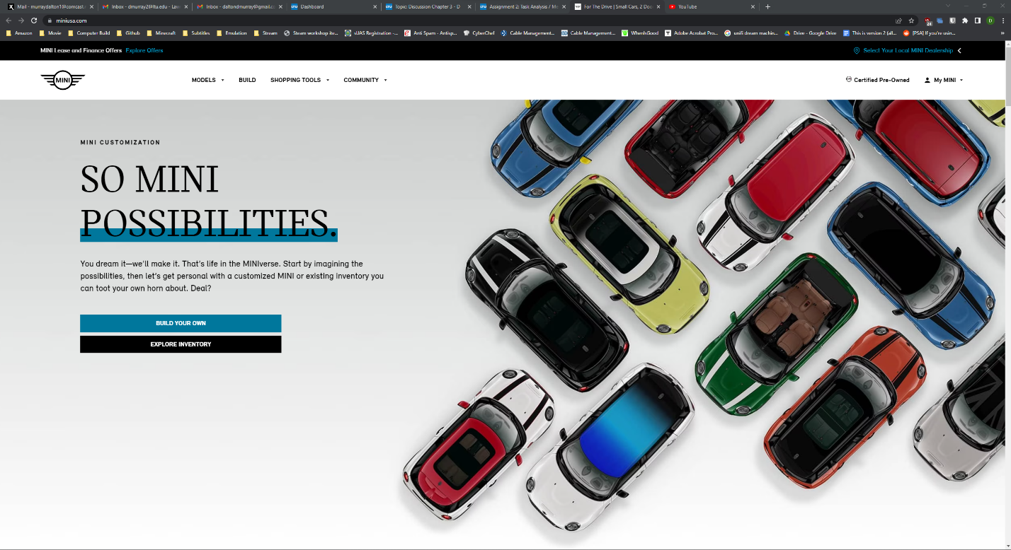

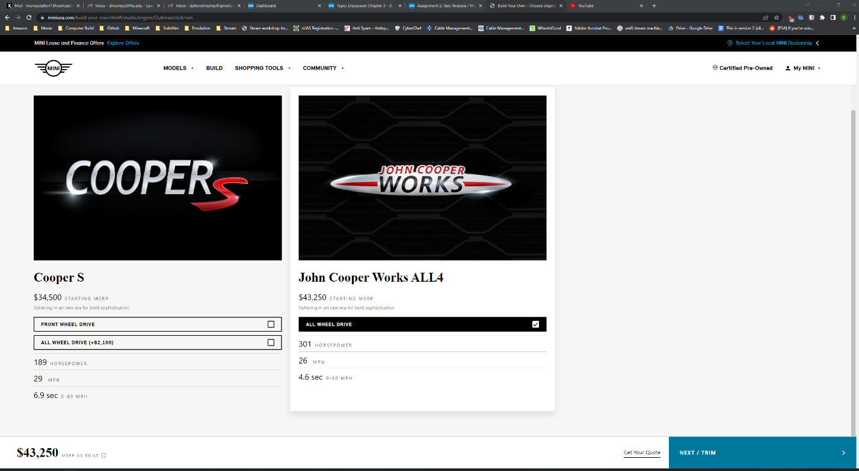

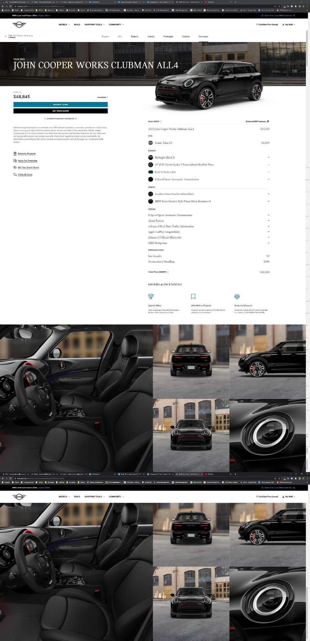

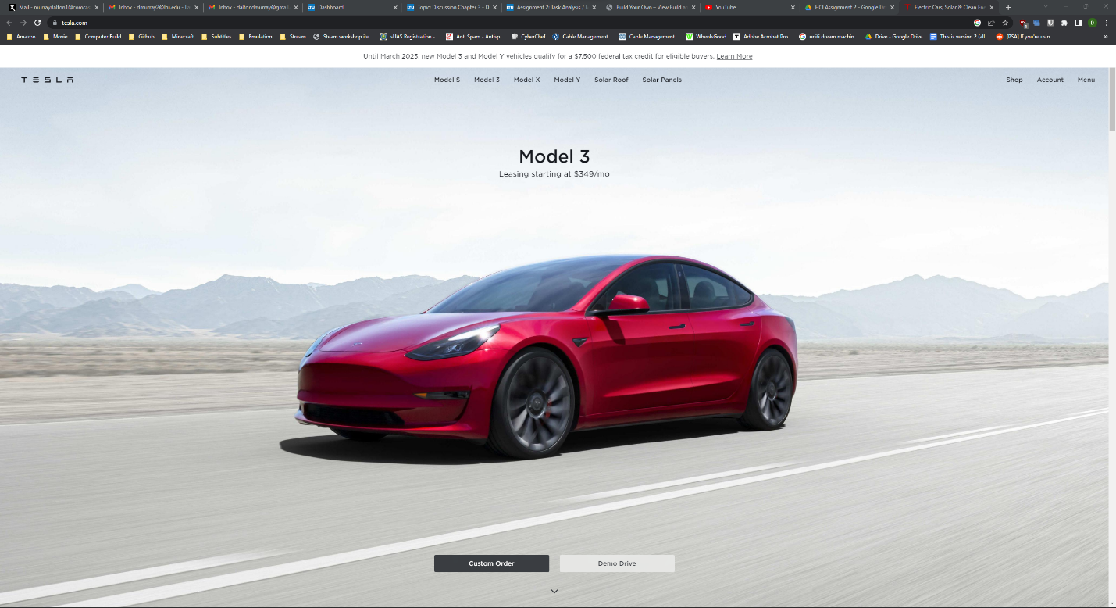

**References**

Kim, G. J. (2015). Human-Computer Interaction: Fundamentals and Practice. Auerbach.

I have neither given nor received unauthorized aid in completing this work, nor have I presented someone else's work as my own.

*Dalton Murray*